USER MANUAL OF CHESS_HUNT ONLINE GAME

After running the server a button will appear. Then just press it..server will start..you can stop server.

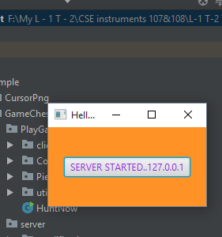

First you have to run the ServerMain class from the server PARt

Then after running the server you have to run HuntNow from PlayGame part

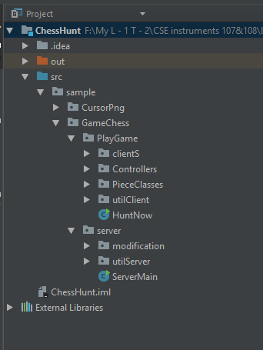

HuntNow and ServerMain are the main class for client and server

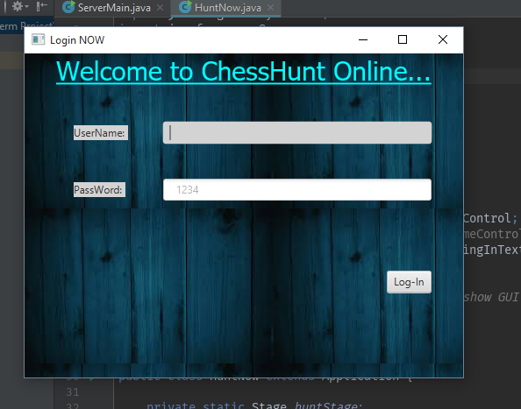

You have to login using a username and a password(random!)

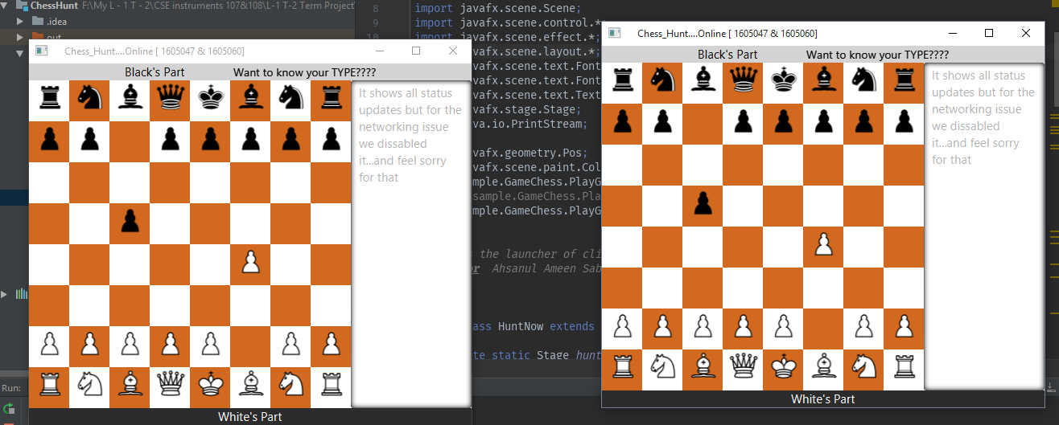

You can play your game…right now

We didn’t provide the offline version due to lack of time

//try to follow this manual it’s not hard to understand it

//but hard to play

//We have some errors in our checkmate program(bugs)

But we’ll try to remake it soon ..

Thank You/